Name : Suraj sharma

First step: 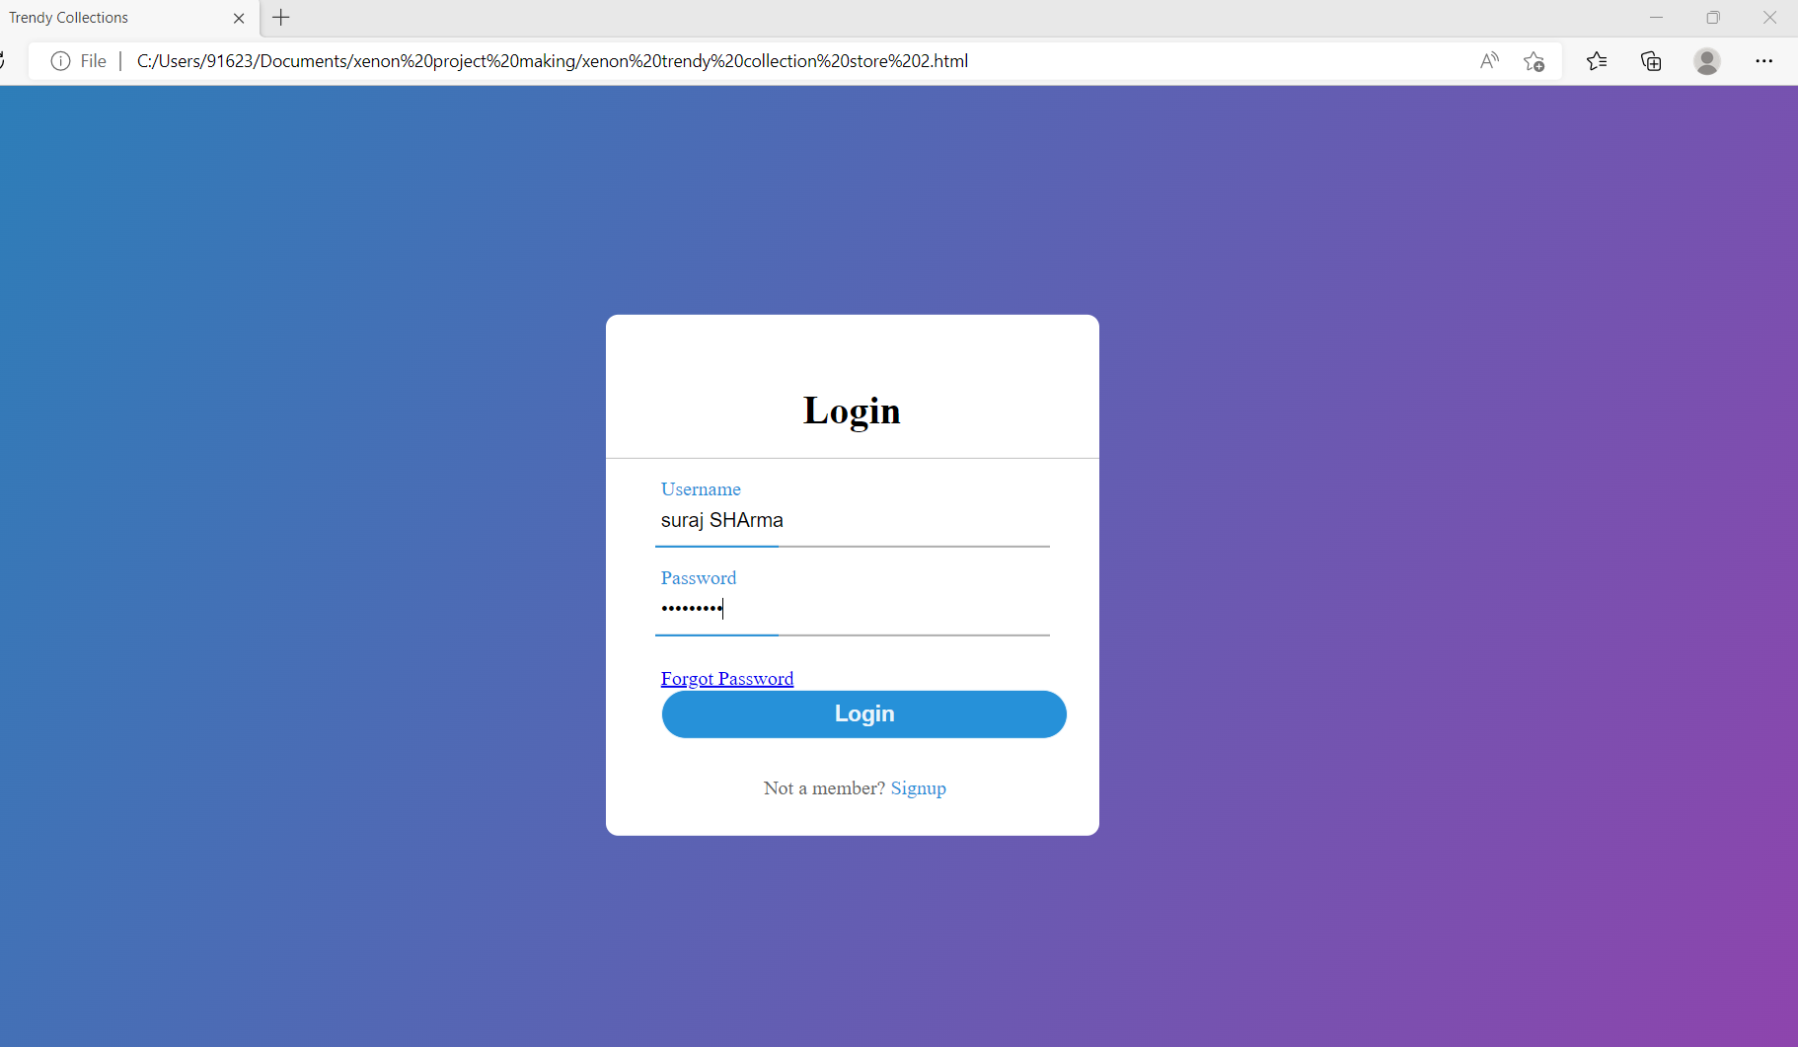

Second Step

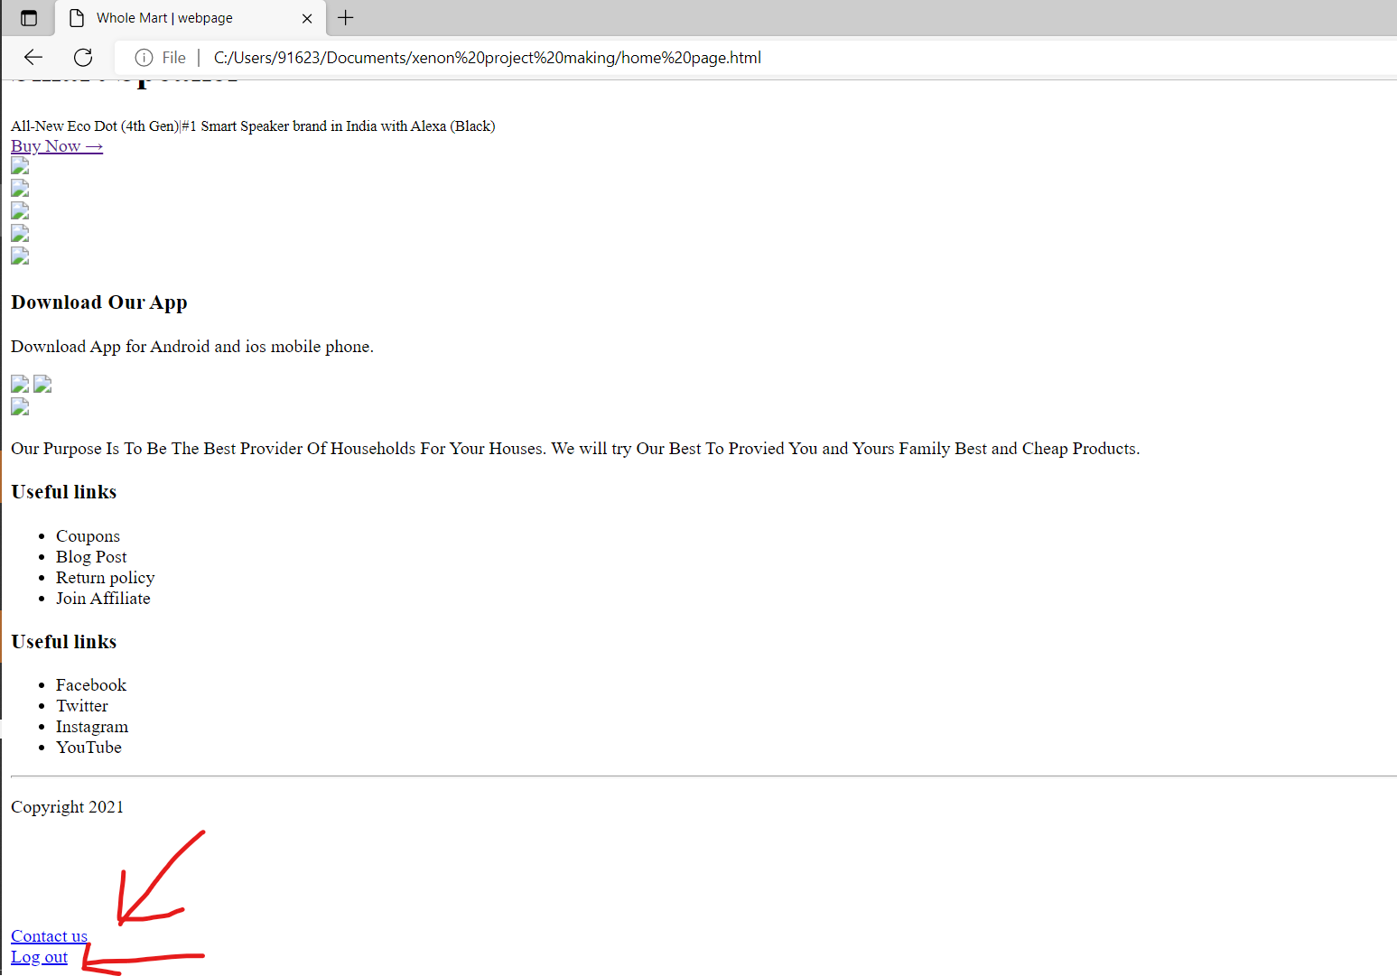

**Third step :**

**After clicking on contact us option**

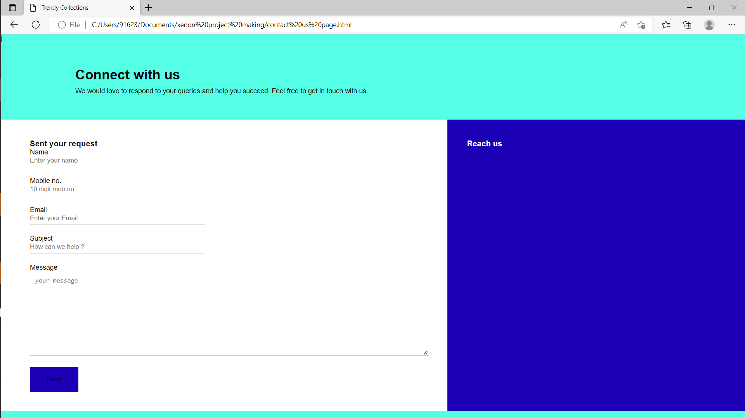

**After clicking on Log out**

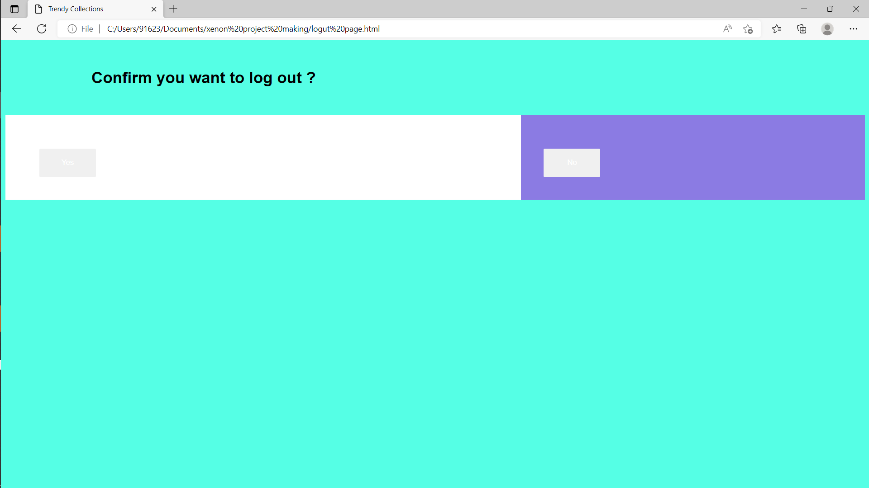

**If we click on yes then we are redirected to login page and if we click on no then we are redirected to Home page .**